**Ideation Phase**

**Brainstorm & Idea Prioritization Template**

|  |  |
| --- | --- |
| Date | 19 September 2023 |
| Team ID | 0C3EDBD66A7F4ADA03A4EC3605388EAF |
| Project Name | |  | | --- | | Data Titans: Unearthing Trends from LinkedIn Influencers | |  | |
| Maximum Marks | 4 Marks |

**Brainstorm & Idea Prioritization Template:**

**Reference** :

<https://app.mural.co/t/nm7600/m/nm7600/1698745201865/ad482924ea466ff6508be2c47b6192f78a846aeb?sender=u9040912599ec6cbae2137136>

**Step-1: Team Gathering, Collaboration and Select the Problem Statement**

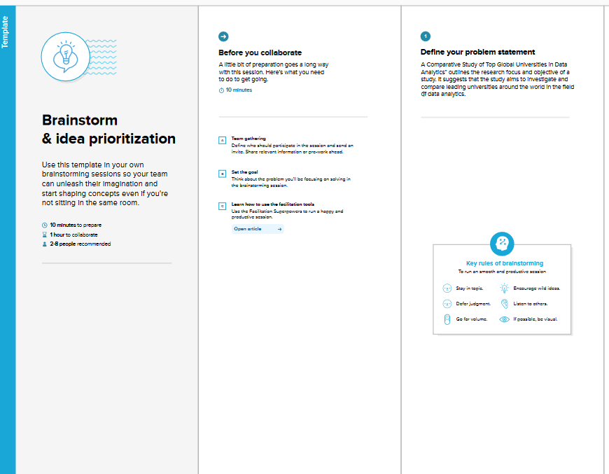

**Step-2: Brainstorm, Idea Listing and Grouping**

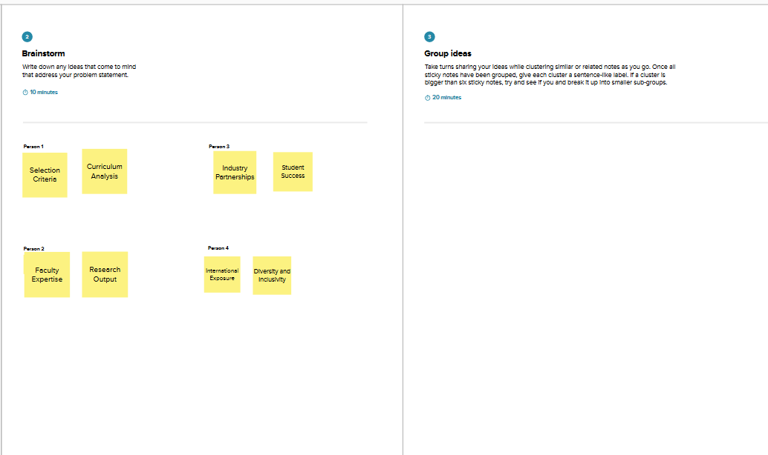

**Step-3: Idea Prioritization**

